* **Training Part -**

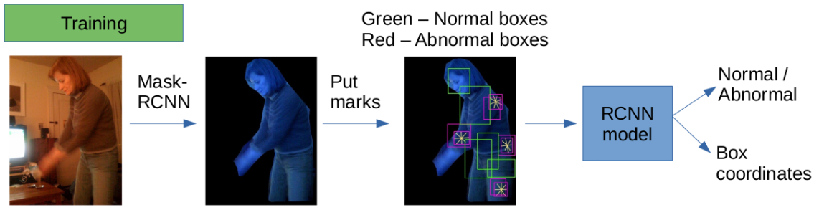

* **Marks put in the training images – (with different sizes)**

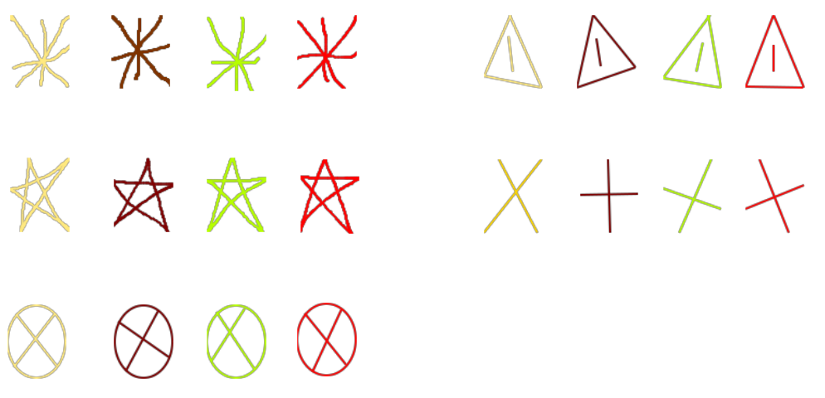

* **RCNN Model Used for Training -**
* Faster RCNN (pretrained on COCO dataset)
* 1500 iterations
* Train – 2090, Validation – 114, Test – 897
* **Training Result -**

Average Precisions (AP) of Bounding Boxes,

AP : 84.21

AP50 : 95.03

AP75 : 94.00

Apm : 95.80

Aps : 81.18

cls_accuracy : 0.9941

false_negative : 0. 0121

fg_cls_accuracy : 0. 9941

loss_box_reg : 0. 0703

loss_cls : 0. 0142

loss_rpn_cls : 0. 0003

loss_rpn_loc : 0. 0044

total_loss : 0. 0902

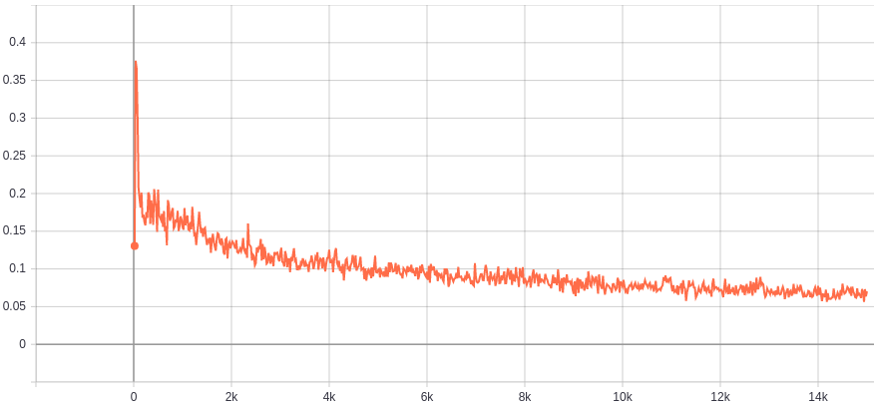

Figure.1: Bounding Box Regression Loss

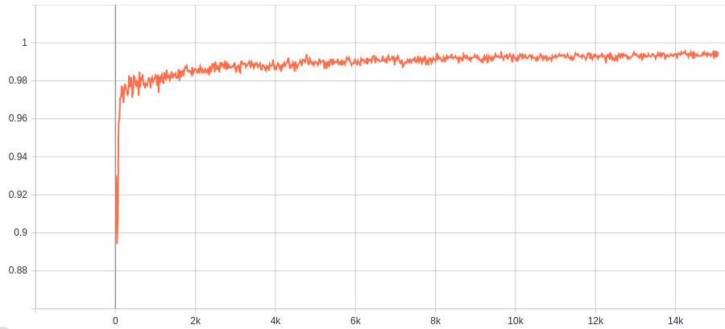

Figure.2: Class Accuracy

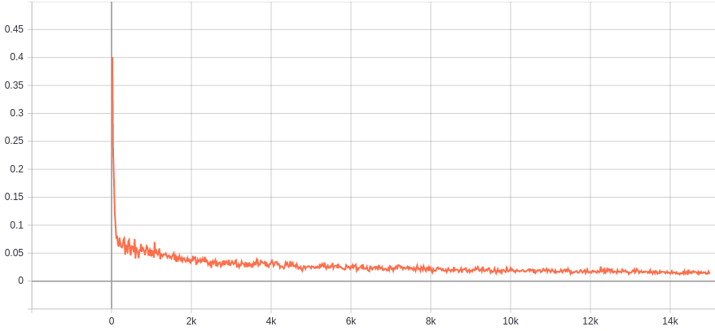

Figure.3: Class Loss

* **Test Result -**

Average Precisions (AP) of Bounding Boxes,

AP : 84.71

AP50 : 97.01

AP75 : 94.95

Apm : 93.821

Aps : 81.86

* **Random Test images with prediction from trained model**

|  |  |
| --- | --- |
|  |  |
|  |  |
|  |  |
|  |  |
|  |  |